**< WEEKLY REPORT FOR WEEK 9 >**

Name: Oh SuJin

Project: Multimodal Sensor Interfacing, Acquisition and Visualization

**I) Project Work Summary**

**Finished:**

* Developing iFarm assessment (intelligence) unit
* Designing iFarm wristband prototype with Lilypad Arduino

**Ongoing:**

* Java-arduino bluetooth communication
* Java-unity communication using RabbitMQ

**II) Tasks Assigned**

**III) Detailed Activities / Accomplishments**

**DAY1&2**

* For analysis and evaluation purpose, hand tracking data is stored in real time in CSV file format. To better identify how tracking data is changed while each rehab exercise is carried out, graphs are plotted based on the CSV data obtained.

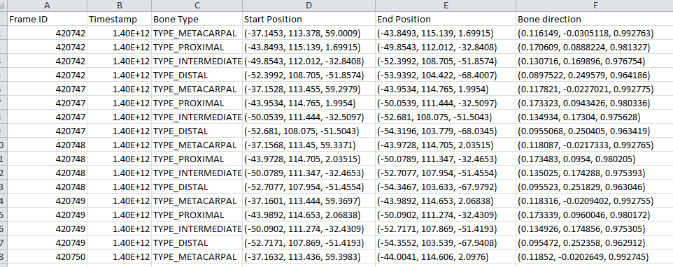

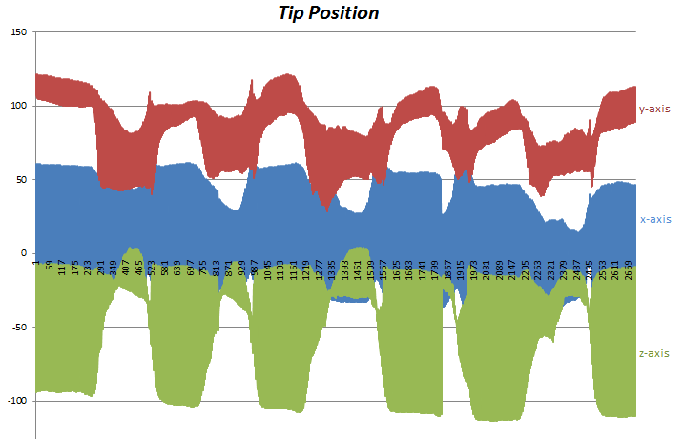

* This visually helps me identifying which data most explicitly signifies the successful carry out of each exercise, providing the fundamental knowledge required for developing data assessment unit. For instance, the starting position of hand (original) could be

1. Grab and pinch strength = 1

2. 0.8< |value of palm’s z direction and y normal vector|<1.1

**DAY3**

* Lilypad Arduino, a microcontroller board designed for wearable is used with other actuators like RGB LED, vibe board and buzzer to design a simple prototype of biofeedback wristband. RXTX library is used for communication between Java and the Arduino IDE.

**DAY 4&5**

* Preparation of iFarm presentation slides
* Making iFarm wristband prototype, sewing actuators and lilypad Arduino on the band using conductive thread.